SLOW – Holmwood Common – 2nd March 2003
Competitor Pre-race Information
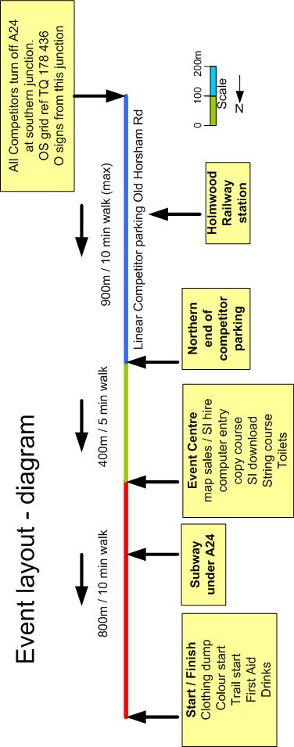

Parking: Linear street parking at Beare Green / Holmwood. This is 4 miles south of Dorking in Surrey. Please share transport if possible. O signs from A24 Grid ref TQ178436 . Watch out for these signs on the road.

If taking part in the trail race you will need to be at the A24 turn off no later than 10 am. If coming south from Dorking you will need to go around the Beare Green roundabout and then come back north (towards Dorking) in order to turn left for Beare Green. Watch out for parking official in yellow bib for where to park on the left hand side of the road, facing north. There are signs about every 200m to indicate how far to the event centre. Follow the red and white markers north (up the hill) towards the event centre) After the race continue north, up the hill, to rejoin the A24. Although Holmwood railway station is next to the parking area there are no trains on Sundays. .

Event centre: Please get changed in your car and take every thing with you to the event centre, including money and entry form, a marked plastic bag for clothing to leave at the start, and a plastic bag to protect your map (colour coded courses only). Please complete your entry form before you register. At the event centre you can:

1: buy your map (colour coded) OR pay for and collect trail race number
2: hire a Sport Ident (SI) card (or use your own card)
3: register on the computer for your course (unless pre-entered)
4: copy your course from master maps (colour coded only)
5: fill in an optional SAE for results (30p) – results also on web site

There are also toilets, and you can get information about the courses and orienteering in general. Trail competitors should pin their race numbers to their chest (pins provided).

There is also an exciting free string course at the event centre for children. There are no changing facilities. The event centre is open from 9am until 11.45am. There is an SI check at the exit of the event centre which checks that your SI card is working which all competitors must use. All competitors must follow the marked route to the start (red and white markers) and MUST use the subway to cross the A24.

Registration: at event centre from 9am to 11.45am or advanced entry via SLOW web page at http://www.sloweb.org.uk. If entering on the day please fill in the attached entry form and bring it to the event centre with you. There may be a restriction on numbers entering the trail race on the day.

Costs: Colour coded £4 / £2 (juniors)
Trail race £5 (£4 if using own SI card)
Pay at event centre

Colour coded orienteering Courses: Colour Coded courses from white up to blue: White 1.32km / Yellow 2.19km / Orange 2.93km / Light Green 3.55km / Green 4.48km / Blue 6.86km. Copy your course onto your blank map at the event centre. Go to the start when you are ready, there are no allocated start times. Ask at the event centre if you are not sure which course to do.

Trail Courses
There are also 10km and 6km trail races with a mass start. This is a cross country race between checkpoints (called controls) on the common but you have to choose the route between the controls. The controls are not difficult to find - Technical Difficult 2 (TD2) on a scale of 1-5, but the legs between them are more demanding (TD3) and are mostly on paths.
Race symbols on the map: Start controls finish
Controls have flags like this:

You can take short cuts between controls BUT you must visit all the controls in the correct order. You use a Sport Ident (SI card) at each checkpoint to prove that you have been there.

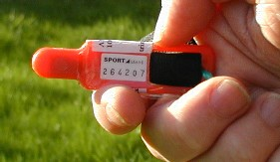

You put the card in the hole in the horizontal control box and it bleeps after a second or so. The SI card is also how you are timed. If you don’t have an SI card you hire one at the event centre and can see how they work on a demo unit. You MUST go to the finish and then the Event centre after the race to download the data on the card and hand in hired cards. If you loose a hired SI card you will be charged a £20 replacement fee.

Clothing / Equipment: For normal orienteering races you have to wear long trousers and shoes suitable for muddy paths. For the trail race you can choose to run in shorts / spikes as most of the course will be on paths. Most orienteers also carry whistles for safety during a race and use a compass for navigation, but you do not need this for the trail race. A clear plastic bag for your map is useful on the colour coded courses.

Map: New map by Mapworks 2003 at a scale of 1: 10,000
Trail race competitors get a laser printed map with the course printed on the map (and in a plastic bag) at the start. Colour coded competitors get a blank map at the event centre and have to copy their course (pens provided) from master maps.
Terrain: Holmwood Common is owned by the National Trust. It is a mix of open common (lots of bracken) and deciduous trees. There are lots of paths.

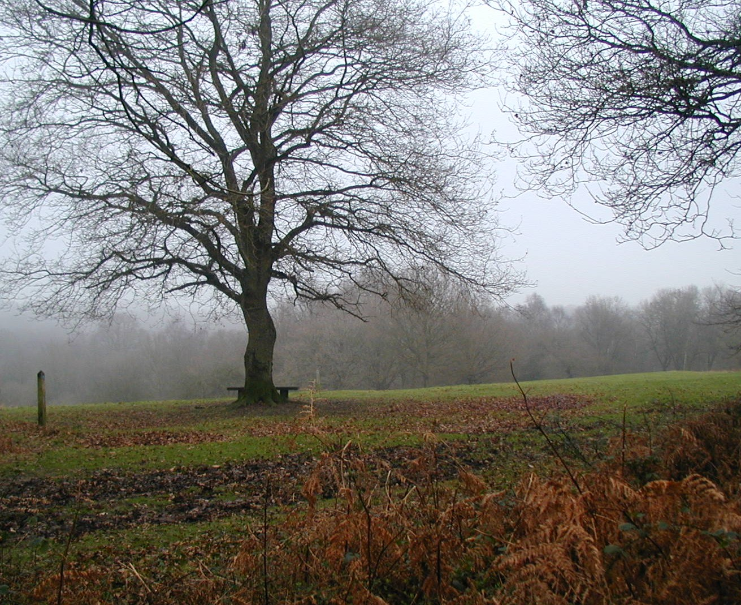

Starts: Colour Coded 10am to 12.30pm
10km trail start 11am
6km trail start 11.15am

There will be a briefing before the start of the trail races at 10.55am. There will be a clothing dump at the start where you can leave a marked bag but any property left is at competitors own risk. Trail competitors are given a pre-marked map just before the start. There will be first aid available at the event centre.

Finish: The finish is near to the start area, there are free drinks. Even if you retire / abandon the race you must go to the finish and you must put your SI card in the finish control. All courses close at 2.30pm. ALL COMPETITORS MUST RETURN TO THE EVENT CENTRE to download their times from their SI card (and to hand in SI card if hired).

Results: Please check http://www.sloweb.org.uk after 8pm on race day. You can also fill in an envelope at the event centre to receive a paper copy (30p)

Trail race prizes: These will be in the usual categories including women, juniors, and veterans. In the 6km race only women, juniors and super-veterans will be eligible for prizes. The more entries in advance we get the more bottles of wine/beer will be given away.

Post race vehicles: When you return to your vehicle you can exit Old Horsham Road by continuing north (up the hill) to rejoin the A24 main road at the northern end of the parking area.

Competitors take part in this race at their own risk.

Organiser: Andrew Trimble organiser@sloweb.org.uk
Planner: John Dowty
Controller: Jon Coles (Mole Valley)

